ANUDIP FOUNDATION

A Project Report on

**“Furniture Business Management**

**System Project”**

By

Batch: ANP-D0453

Student ID: AF0477127

Name: Nandini Baslingappa Karli.

**Under the Guidance of**

Mrs. Rajshri Chandrabhan Thete.

“**Furniture Business Management**

**System Project**”

# Entities:

* Admin
* Customer
* Furniture
* Inventory
* Order
* Payment
* supplier

# VARIOUS ENTITIES:

* 1. **Admin**
     + **id**
     + UserName
     + Email
     + password

# Customer

* + - **Email**
    - Id
    - password
    - username

# Furniture

* + - ID
    - Name
    - Price
    - Quantity
    - Supplier
    - Type

# Inventory

* + - Change Quantity
    - furniture
    - Id
    - Remark
    - Stock Date
    - Stock Qunatity

# Order

* + - Customer
    - Furniture
    - Id
    - Order Date
    - Quantity
    - Total price

**6.Payment**

* Amount
* Id
* Order
* Payment date
* Payment Method

**7.Supplier**

* Address
* Contact number
* Email
* Furniture List
* Id
* Name

**ENTITY RELATIONSHIP DIAGRAM –**

**Furniture Business Management System Project**

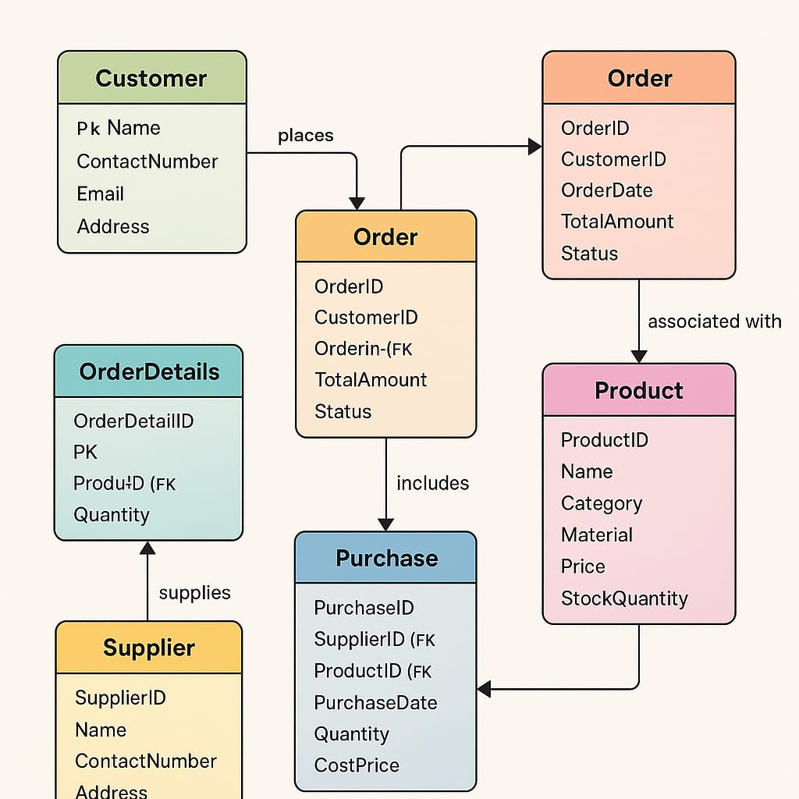

**CONCLUSION:**

In Conclusion, The Furniture Business Management System ER diagram efficiently represents key entities—Customer, Product, Order, Supplier, and their relationships—enabling streamlined management of orders, inventory, and supplier interactions for a well-organized business operation.

# DATABASE CREATION QUERY:

CREATE DATABASE FurnitureBusinessDB;

USE FurnitureBusinessDB;

-- 1. Admin Table

CREATE TABLE Admin (

Id INT AUTO_INCREMENT PRIMARY KEY,

UserName VARCHAR(100) NOT NULL,

Email VARCHAR(100) UNIQUE NOT NULL,

Password VARCHAR(100) NOT NULL

);

-- 2. Customer Table

CREATE TABLE Customer (

Id INT AUTO_INCREMENT PRIMARY KEY,

UserName VARCHAR(100) NOT NULL,

Email VARCHAR(100) UNIQUE NOT NULL,

Password VARCHAR(100) NOT NULL

);

-- 3. Supplier Table

CREATE TABLE Supplier (

Id INT AUTO_INCREMENT PRIMARY KEY,

Name VARCHAR(100) NOT NULL,

Email VARCHAR(100),

ContactNumber VARCHAR(15),

Address VARCHAR(255)

);

-- 4. Furniture Table

CREATE TABLE Furniture (

Id INT AUTO_INCREMENT PRIMARY KEY,

Name VARCHAR(100) NOT NULL,

Price DECIMAL(10,2) NOT NULL,

Quantity INT NOT NULL,

SupplierId INT,

Type VARCHAR(50),

FOREIGN KEY (SupplierId) REFERENCES Supplier(Id)

);

-- 5. Inventory Table

CREATE TABLE Inventory (

Id INT AUTO_INCREMENT PRIMARY KEY,

FurnitureId INT,

StockQuantity INT,

ChangeQuantity INT,

StockDate DATE,

Remark VARCHAR(255),

FOREIGN KEY (FurnitureId) REFERENCES Furniture(Id)

);

-- 6. Orders Table

CREATE TABLE Orders (

Id INT AUTO_INCREMENT PRIMARY KEY,

CustomerId INT,

FurnitureId INT,

OrderDate DATE,

Quantity INT,

TotalPrice DECIMAL(10,2),

FOREIGN KEY (CustomerId) REFERENCES Customer(Id),

FOREIGN KEY (FurnitureId) REFERENCES Furniture(Id)

);

-- 7. Payment Table

CREATE TABLE Payment (

Id INT AUTO_INCREMENT PRIMARY KEY,

OrderId INT,

Amount DECIMAL(10,2),

PaymentDate DATE,

PaymentMethod VARCHAR(50),

FOREIGN KEY (OrderId) REFERENCES Orders(Id)

);